2023 Quick Facts for the Desktop

If the document opens in Word:
- Right-Click on the image below and select SAVE AS PICTURE. By default, it may open to your PICTURES file (you can change the location if you wish)
- Enter a Name, such as 2023 Desktop Quick Facts, and click SAVE.
- Go to your desktop
- Right click on your desktop and select Personalize
- In the Background box, select Picture from the drop-down menu
- In Choose your picture,
  - select Browse,
  - navigate to the place where you saved the attachment,
  - select the picture you just saved,
  - select the Choose Picture button.
  - Under Choose Fit, select Center from the drop-down menu. This allows you to put your desktop shortcuts around the edges of the picture in order to be able to identify them, and still see the facts on both monitors.

If the document opens WORD in EDGE:
- Click the Edit Document menu button (top right) and select Open in Desktop App.
- Right-Click on the image below and select SAVE AS PICTURE. By default, it may open to your PICTURES file (you can change the location if you wish)
- Enter a Name, such as 2023 Desktop Quick Facts, and click SAVE.
- Go to your desktop
- Right click on your desktop and select Personalize
- In the Background box, select Picture from the drop-down menu
- In Choose your picture,
  - select Browse,
  - navigate to the place where you saved the attachment,
  - select the picture you just saved,
  - select the Choose Picture button.
  - Under Choose Fit, select Center from the drop-down menu. This allows you to put your desktop shortcuts around the edges of the picture in order to be able to identify them, and still see the facts on both monitors.

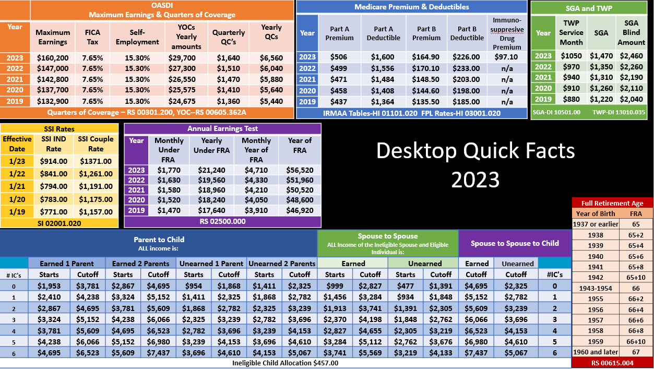

IMPORTANT: Do not save changes to this document when you are finished.

